Divide by Two-Digit Numbers
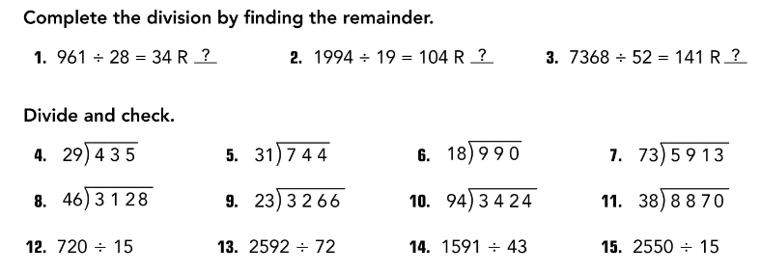
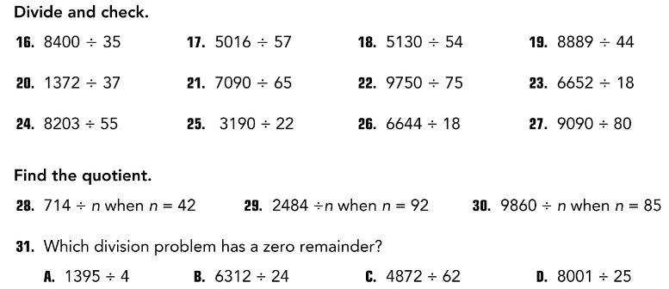

32. An art class uses 3744 ounces of clay making ceramic pots. Each student makes 12 pots like the one shown. How many students are in the class?

